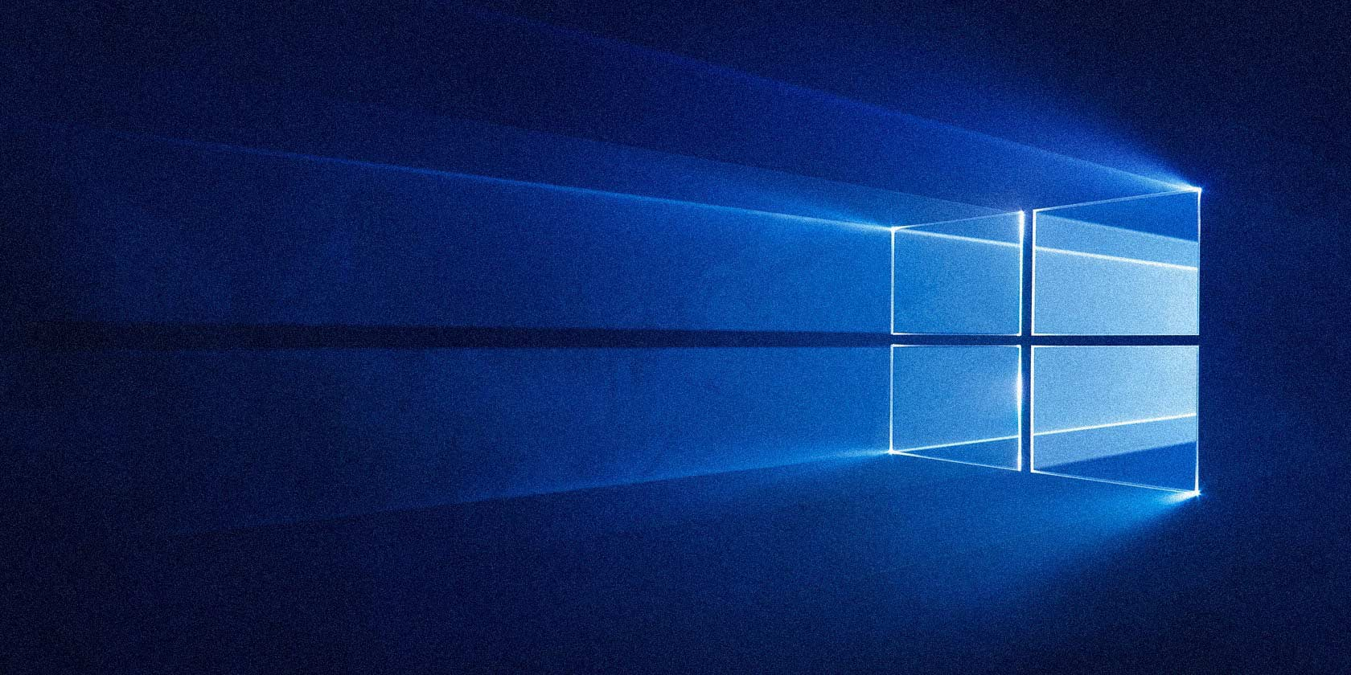

Control Panel: Windows 10

Samantha Marvelle

Term Project 11/17/17

**Table of Contents:**

Control Panel

Administrator Tools Component Services

Computer Management

* + Defragment and Optimized Drives
  + Disk Cleanup
  + Event Viewer
  + ISCSI Initiator
  + Local Security Policy
  + ODBO Data Source (32-bit)
  + ODBO Data Source (64-bit)
  + Performance Monitors
  + Print Management
  + Resource Monitor
  + Services
  + System Configuration
  + Task Scheduler
  + Windows Firewall with Advanced Security
  + Windows Memory Diagnostics

AutoPlay

Backup and Restore

Color Management

Credential Managers

Date and Time

Default Programs

Device Manager

· Audio input and output

· Batteries

· Bluetooth

· Computer

· Disk Drivers

· Display Adapter

· DVD/CD-ROM Drivers

· Firmware

· Human Interface Devices

· IDE ATA/ATAPI Controller

· Imaging Devices

· Keyboard

· Mice and Other Pointing Devices

· Monitors

· Network Adapters

· Portable Devices

· Print Queues

· Processors

· Security Devices

· Software Devices

· Sound, Video, and Games Controllers

· Storage Controllers

· System Devices

· Universal Serial Bus Controller

Devices and Printers

Ease of Access Center

File History

Flash Player

Fonts

Infrared

Inter® Graphic and Media

Keyboard

Language

Mail (Microsoft)

Networking and Sharing

Phone and Modem

Power Options

Recovery

Region

Sound

System

Taskbar and Navigator

Windows

How to get to the Control Panel: On Windows 10 you can use Cortana, type Control Panel

  Press enter, you will see this screen

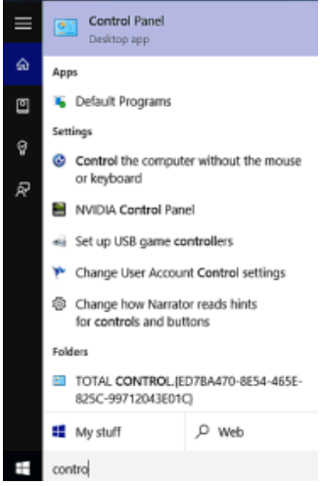

On Control Panel, the most commonly used is the Administrative tools. The use of the other programs just not as much. Control; Panel controls the different uses for the computer.

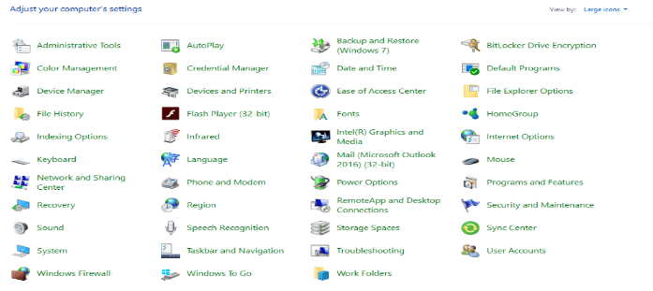

Administrators tools: Administrators tool shows you the different type of tools you can use for the system. 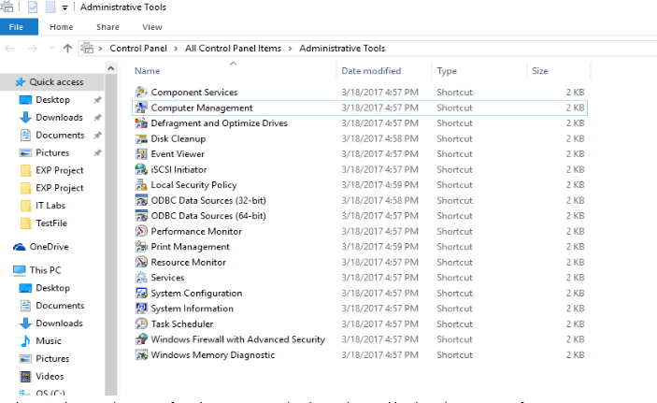

On Admin Tools is another name for administrator tools. This tool is used by the Administrator, if a user wants to use this tool they need the information to use the tools. Commonly used on admin tools is Computer Management, Event Viewer, Local Security Policy, Performance Monitor, System Configuration, System Information, and Task Schedule

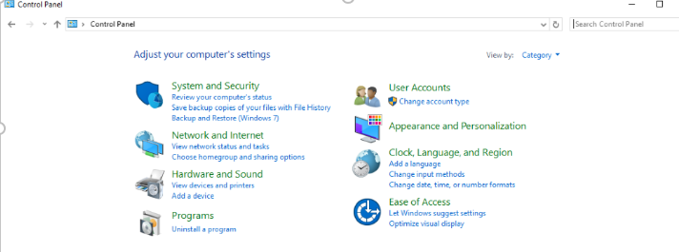

Computer Management: For this tool, you have a few choices to get information about the system. Most common we use System tools. System tools has other folders within that program, the most frequently use Local Users and Groups.

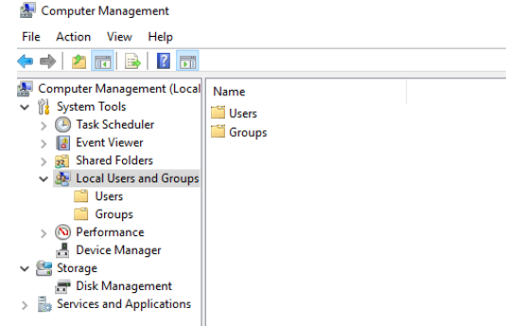

The Local User and Groups is used for sharing different files with people on a different network, you can set it up the way the users see the files, you can also make them change their passwords if they are secure enough.  User is most commonly used.

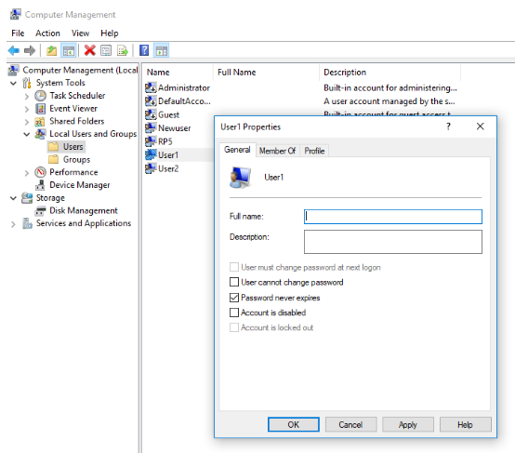

Component Services: Manages the COM+ application, COM and DCOM system configuration, and then Distribution Transaction Coordinator.

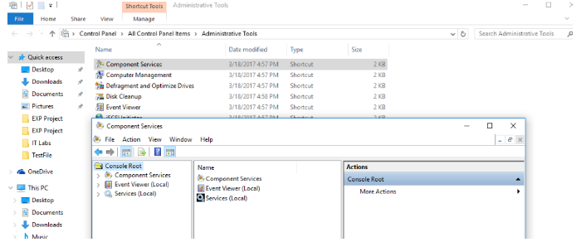

The Component Services tab looks like:

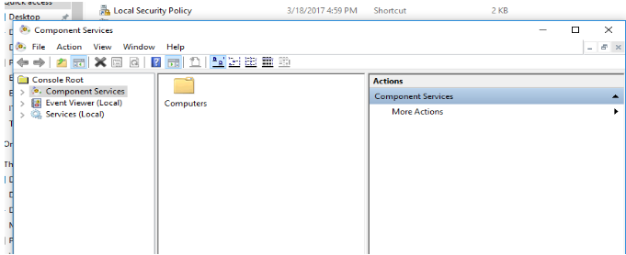

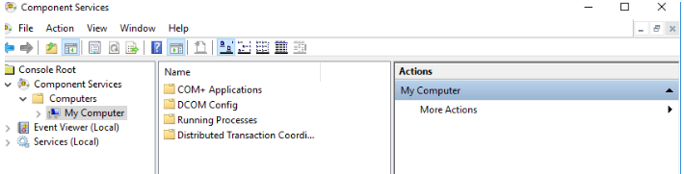

Defragment and Optimize Drivers: It optimize files and fragments on your volume so that the computer can run faster and more efficiently.

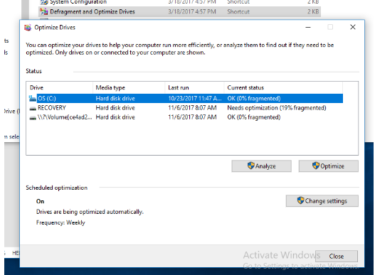

The picture shows the different drivers in the computer, and it gives you the option to optimize them. It also shows you the last time the drive was run, it also shows what the statues of the drive.  You can choose when you want it to get optimized.

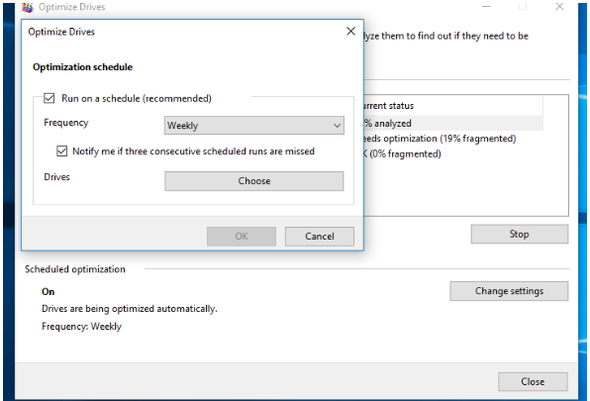

Disk cleanup: This program helps clean up your system for unneeded files, temporary files, recycle bin, and more to clean your system. This program is used to free up more storage on your PC, make sure that you have a backup incases your end up deleting something important.

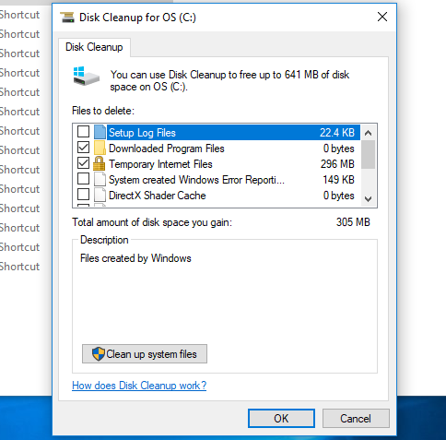 To erase the files or anything else the disk cleanup and delete make sure you have the boxes checked off. The most often used like temporary internet files and download program files are already checked off for you. This program is very useful and is easy to use. 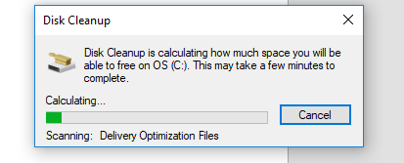Once this scan is done you can check anything you have had deleted.

Event Viewer: It shows what it has monitored bout the program. It shows you if it passed the test or if it failed. 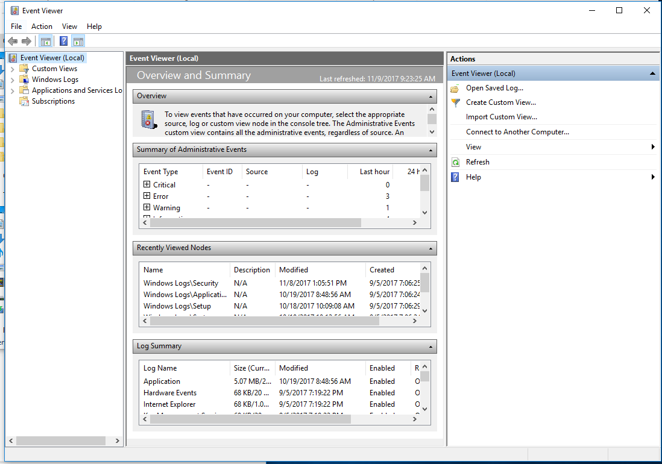It also monitors the troubleshooting messages from Windows and other programs. Event viewer is helpful, and you should check regularly. It gives and description onto what went wrong with the program. And if you double click the program with the issue then it will should you what went wrong.

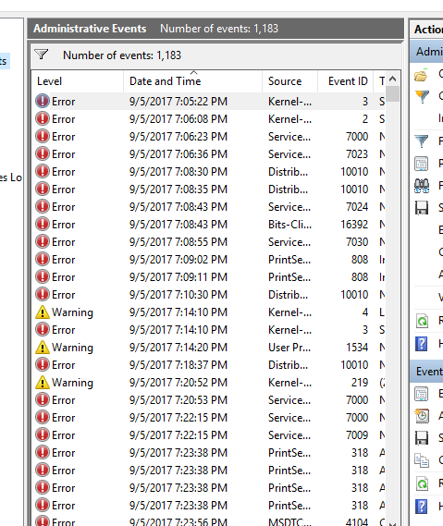 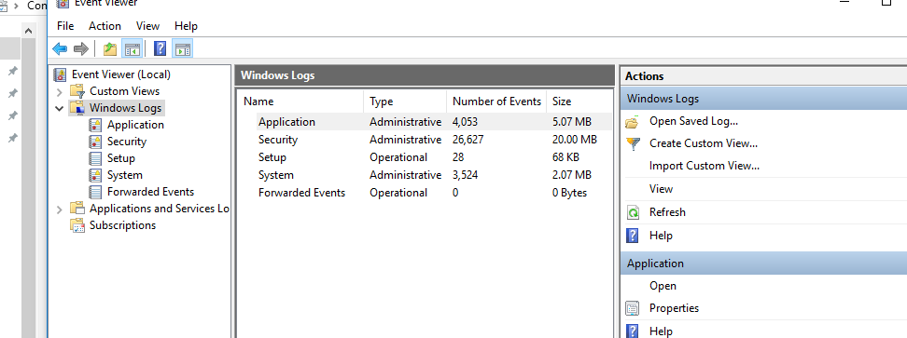

iSCSI Initiator: An initiator typically serves the same purpose to a computer as a SCSI bus adapter would, except that, instead of physically cabling hard drives iSCSI initiator sends SCSI commands over an IP network. 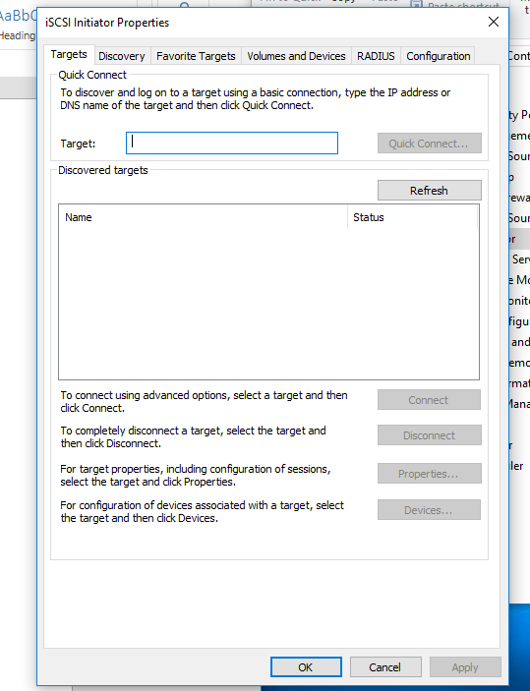 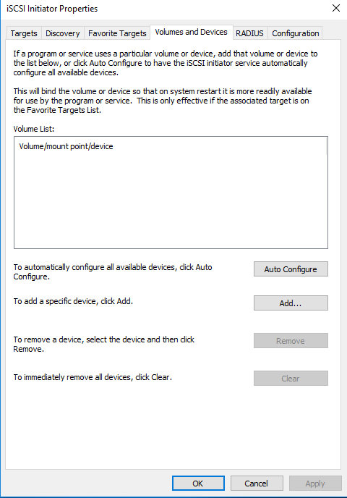

Local Security Policy: It views and modifies local security

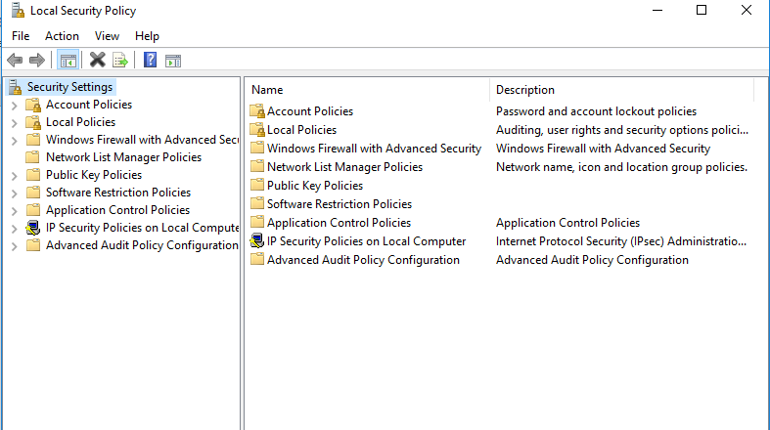 On local security policy can make things audit. It also tells you security settings of the policy. It's really easy to use. If you want to change the policy to failure or success then double-click the program, then check the box either success or failure, apply, then ok. And u have successfully changed the policy.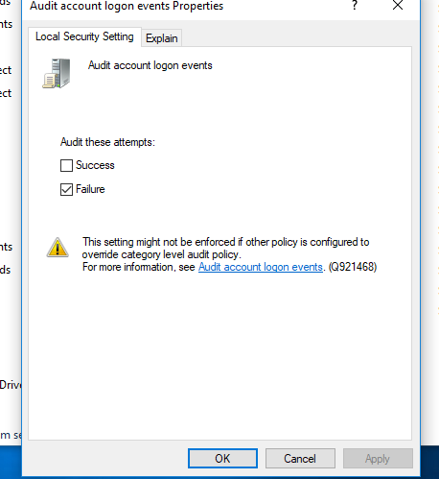

ODBC Data Source (32-bit)- Administrator manages the database driver and data sources.

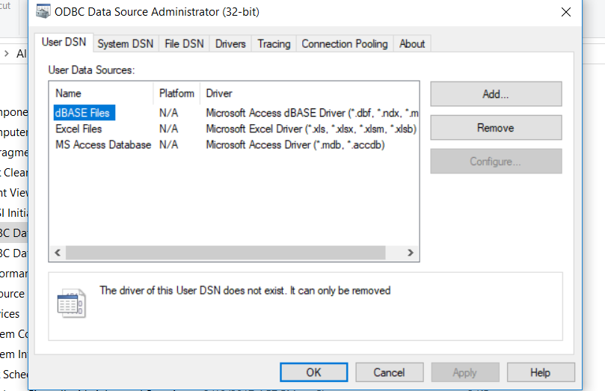 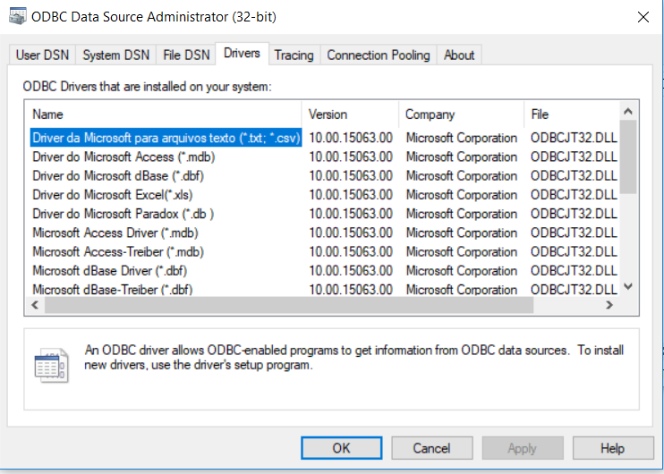

ODBC Data Source (64-bit)- maintains the ODBC data source and drivers

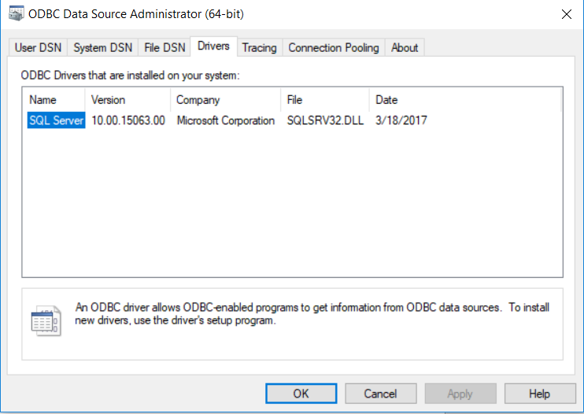 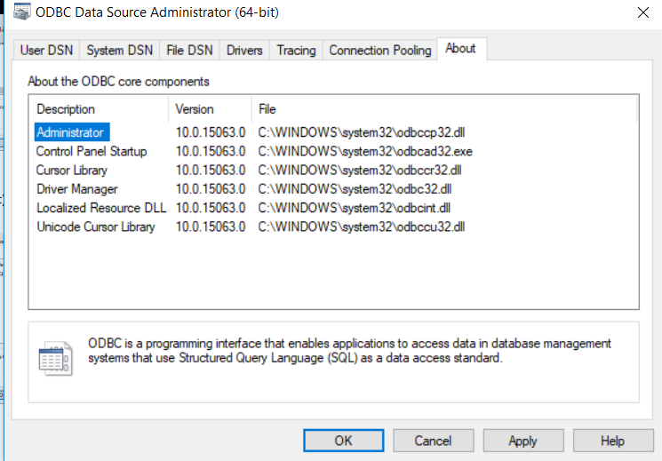

Both deal with the DNS. These are data source being a specific set of data, the information required to access that data, and the location of the data source, which can be described using a data-source name.

Performance Monitor- It diagnose performance issues and collects performance data

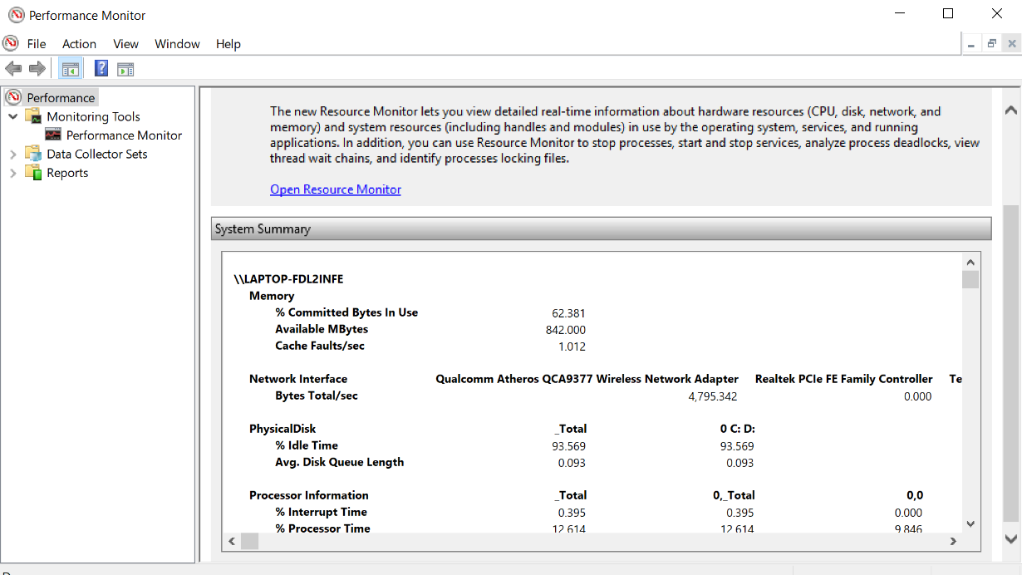 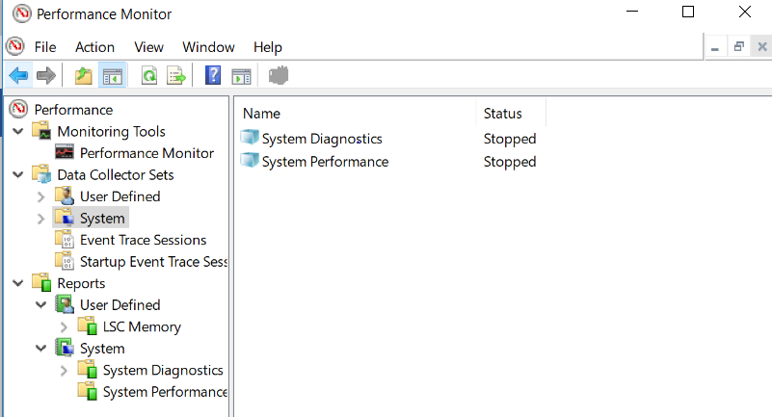

Print Management: This tool is for managing printers and remotes drivers.

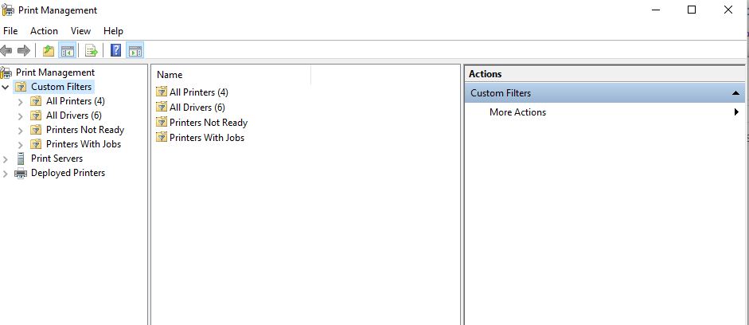

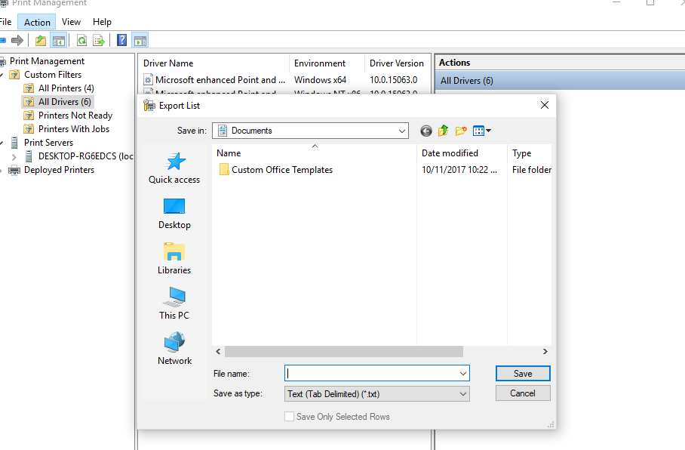You can also create a new printer to print to. You can configure where, what folder and files, you want to print.

Resource Monitors- you can monitor the resource you have used to see if they have any issues.

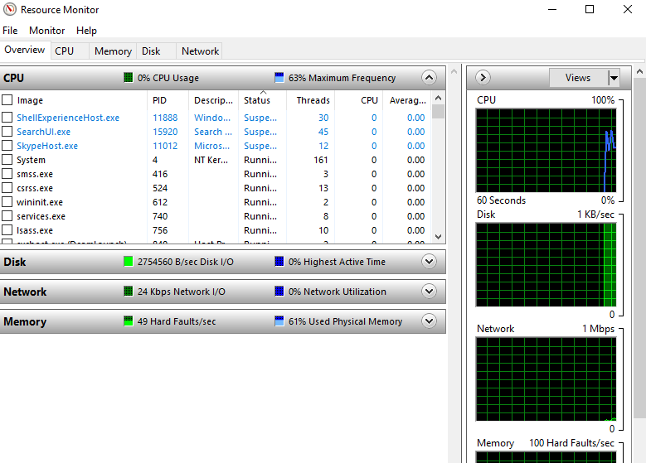It also gives the states of the application. In addition to that it tells you if the application is up and running.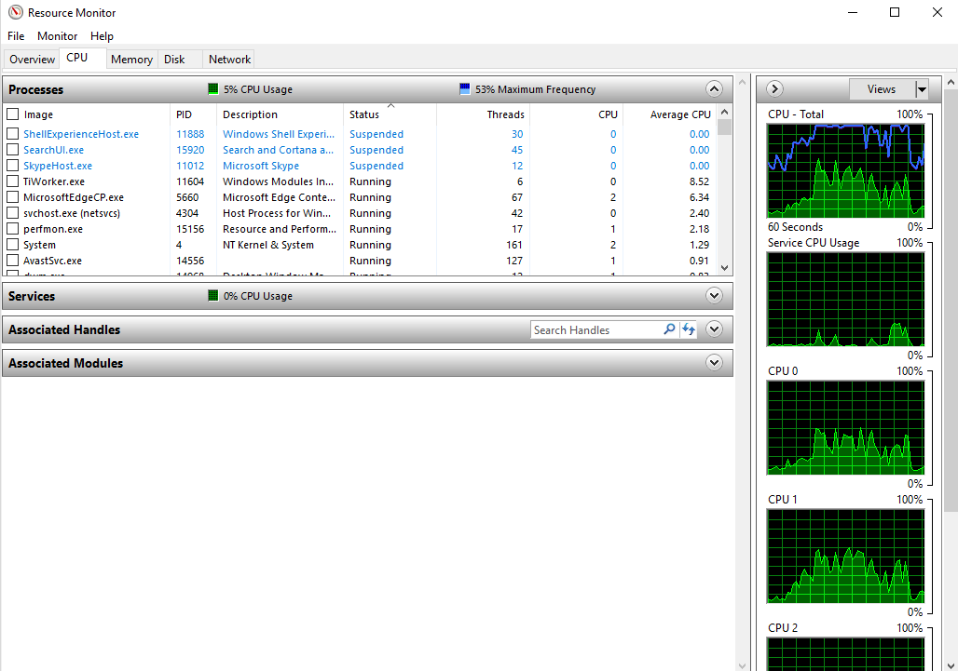It gives you information about your running system like the CPU, Memory Disk and Network about their statues.

Services- It starts, stops, and configures the Window services.

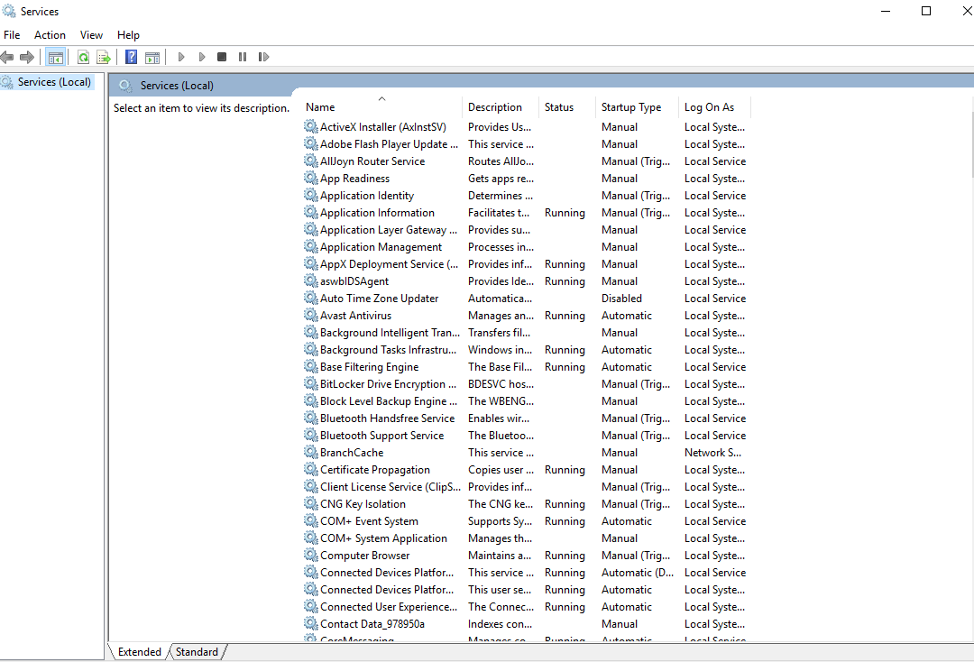 You may also connect to other computers, you can connect any computer either in the network or another computer. 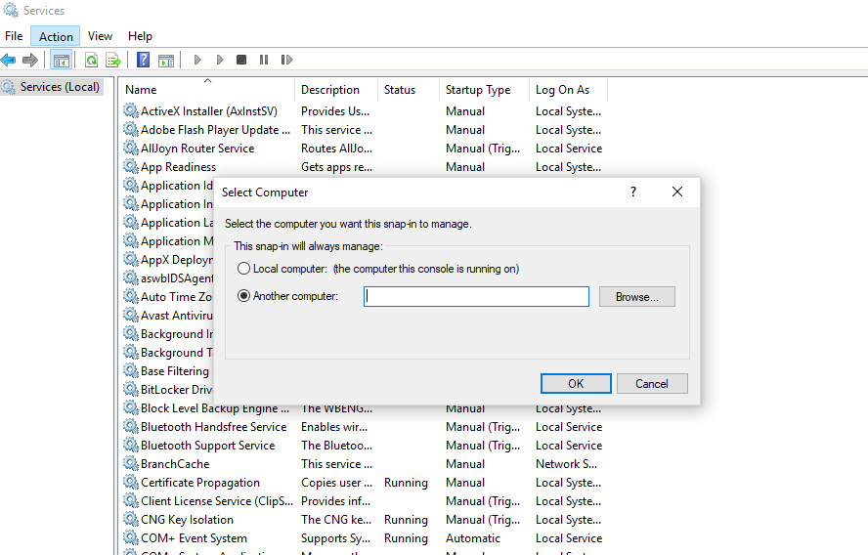

System configuration- It preforms more advanced troubleshooting and system configuration.

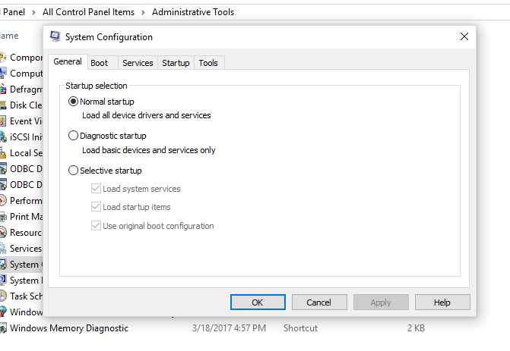This program helps with diagnosing problems with your system. System configuration is also used to configure your program. Mainly for the booting your system.

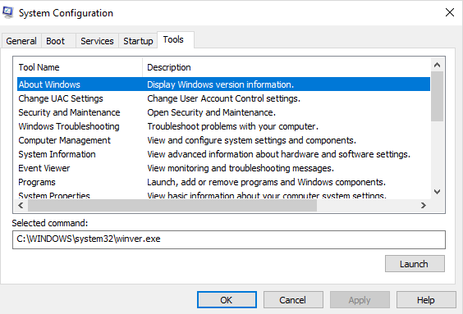

Task Scheduler- It's a scheduler for the task that you are running. You can create and schedule common task needed for your computer. 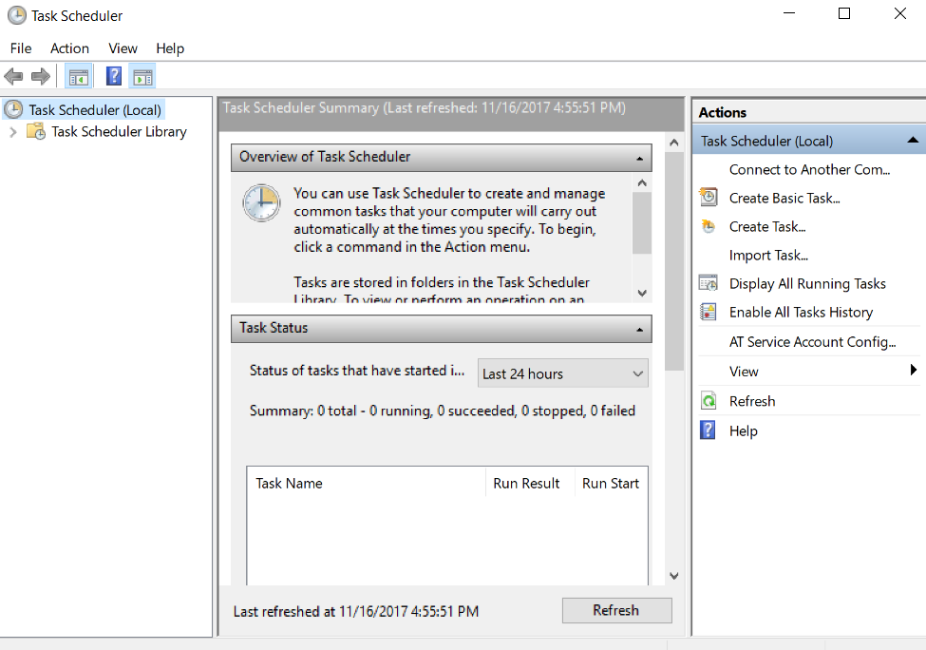Under task scheduler library there is more options for your computer. Task scheduler can show the last time something was running and you can change the setting of task scheduler to what you want.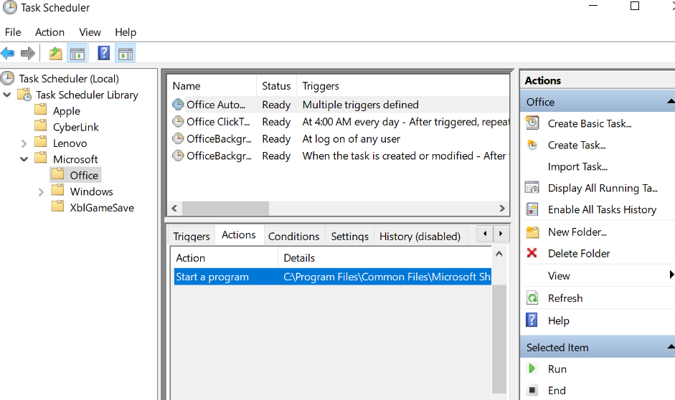

Windows Firewall with Advanced Security- supports separate profiles (sets of firewall and connection security rules) for when computers are members of a domain, or connected to a private or public network. It also supports the creation of rules for enforcing server and domain isolation policies.

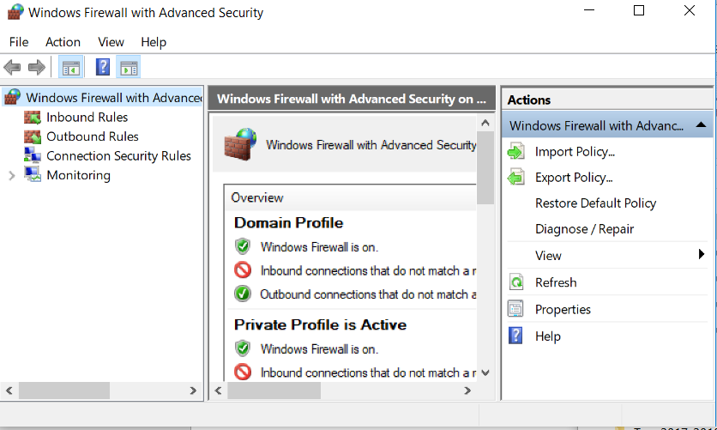 There are features that enable you to create firewall and connection security rules, Windows Firewall with Advanced Security includes built-in tools for monitoring the firewall and the IPsec connections you make to other computers.

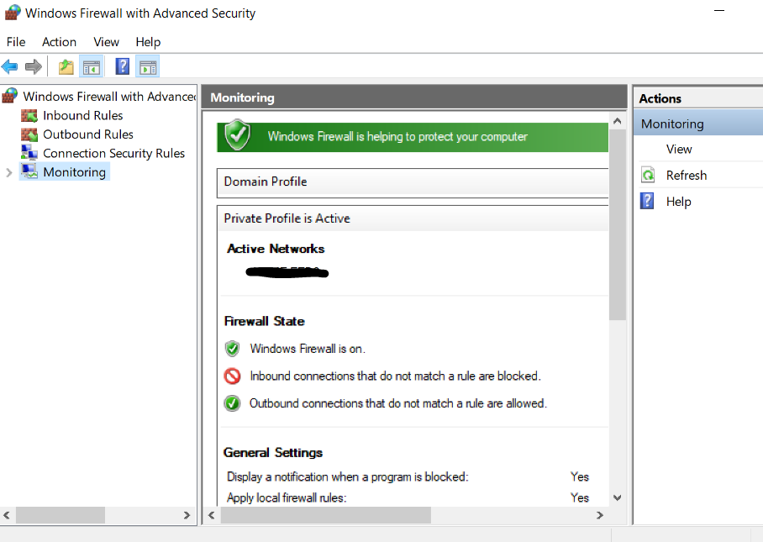

Windows Memory Diagnostics- Checks the computer for memory problems.

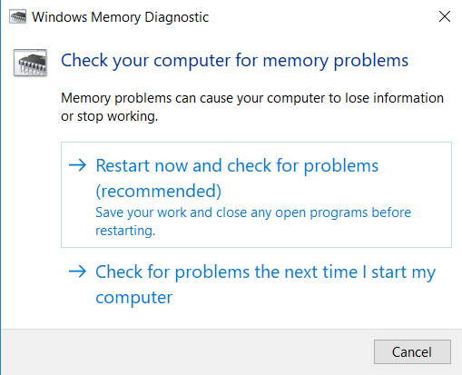This process takes about 5 minutes to test your RAM. As its test the memory it shows you if there is any errors detected in the system.

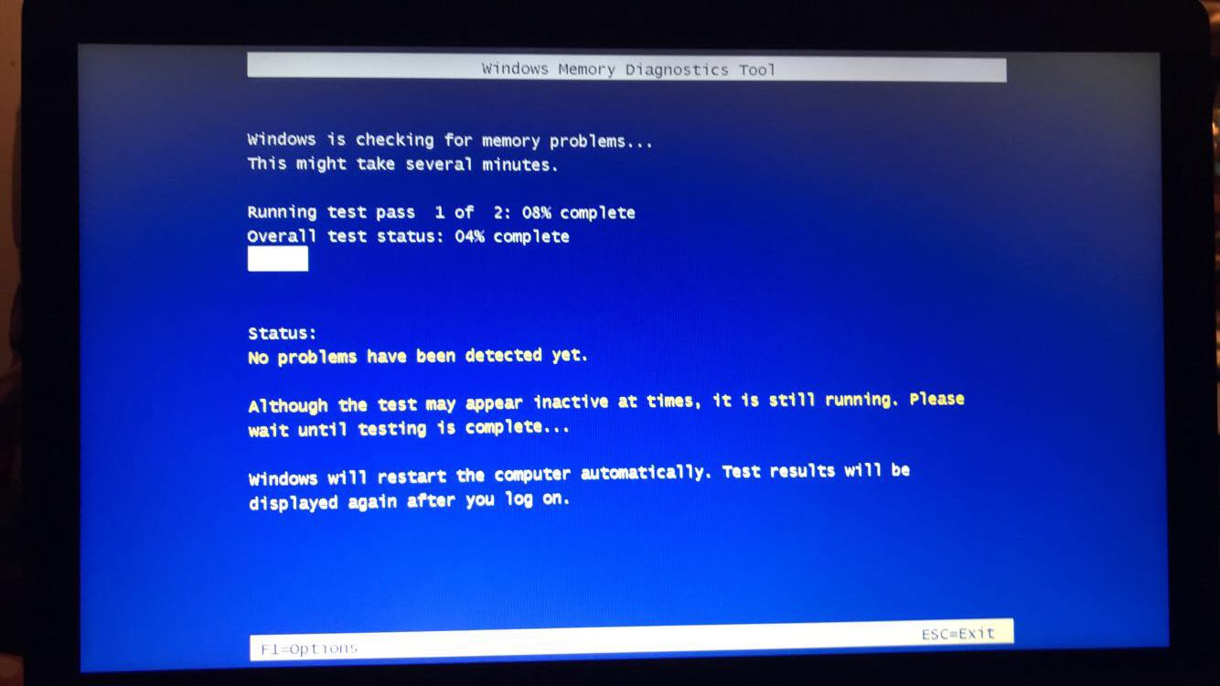

AutoPlay- Changes default settings for CDs, DVDs, and devices so that you can automatically play music, view pictures, install software, and play games

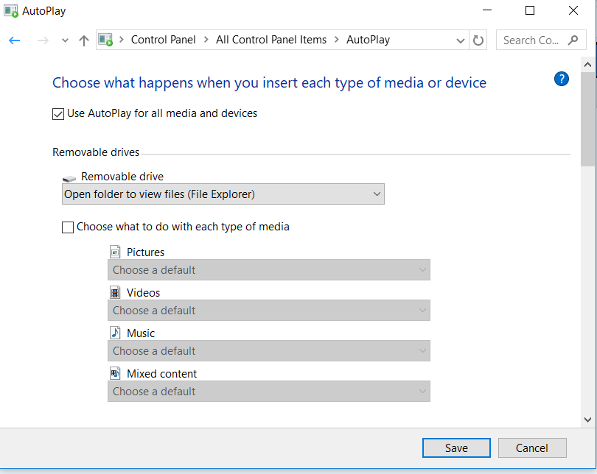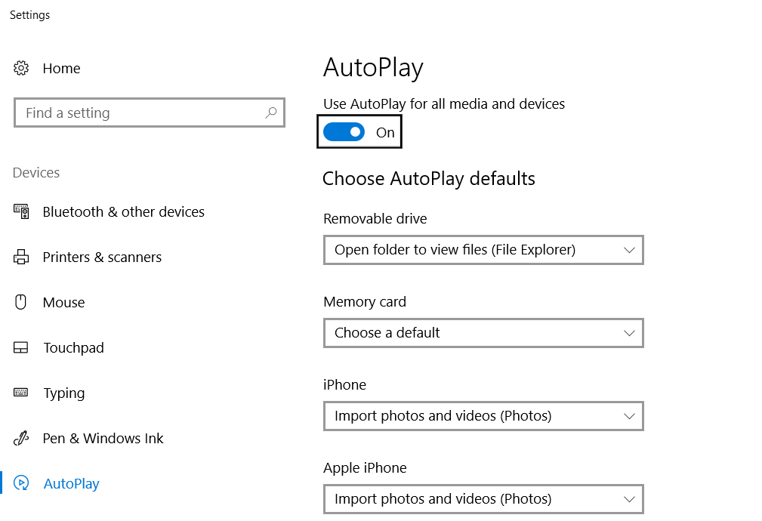 You can also find auto play in settings

Backup and Restore- configure the system backup and create a restore point in case something bad happens to your system. 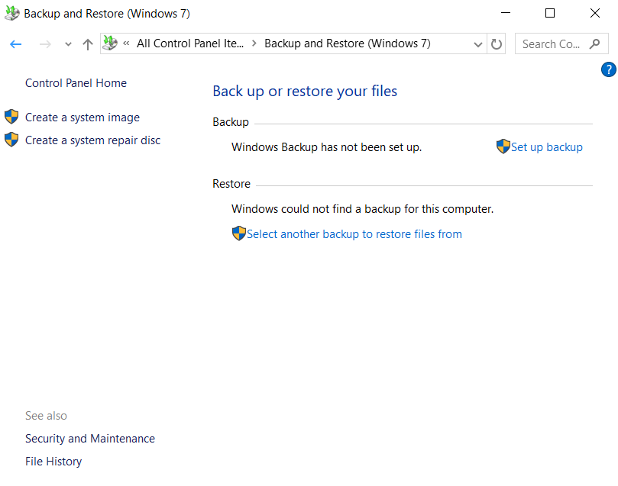 It is very useful to have a backup and restore point your computer. Say you downloaded a malicious software makes your computer not boot up properly you can restore it back too before the software was downloaded.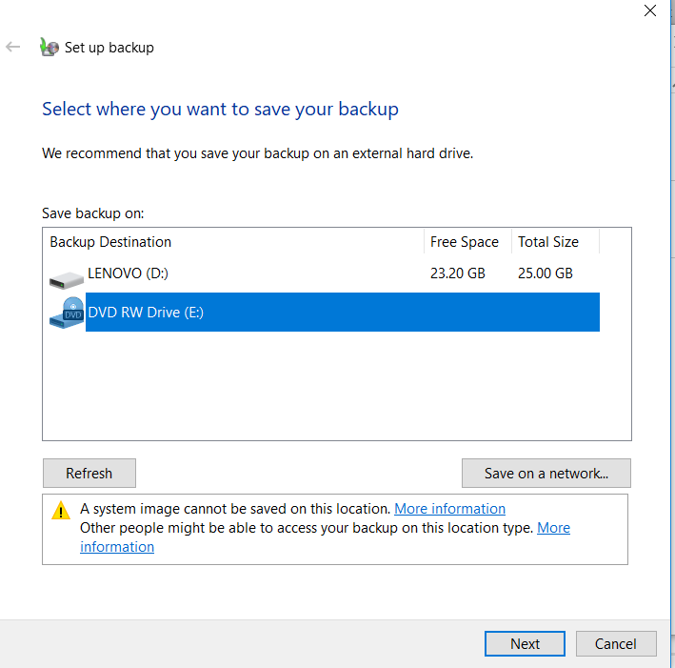

Color Management- is the controlled conversion between the color representations of various devices, such as image scanners, digital cameras, monitors, TV screens, film printers, computer printers, offset presses, and corresponding media.

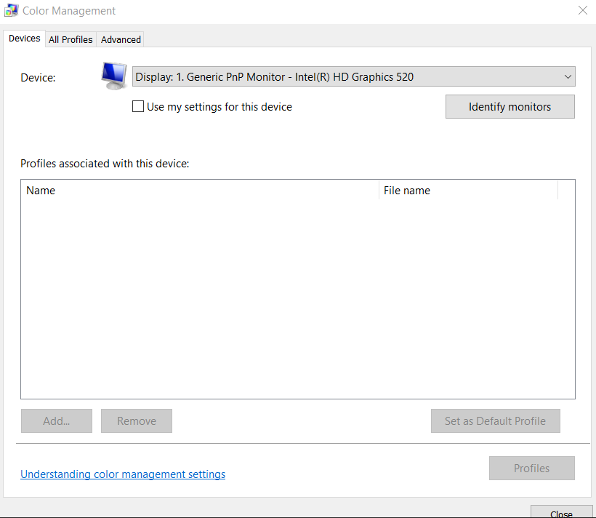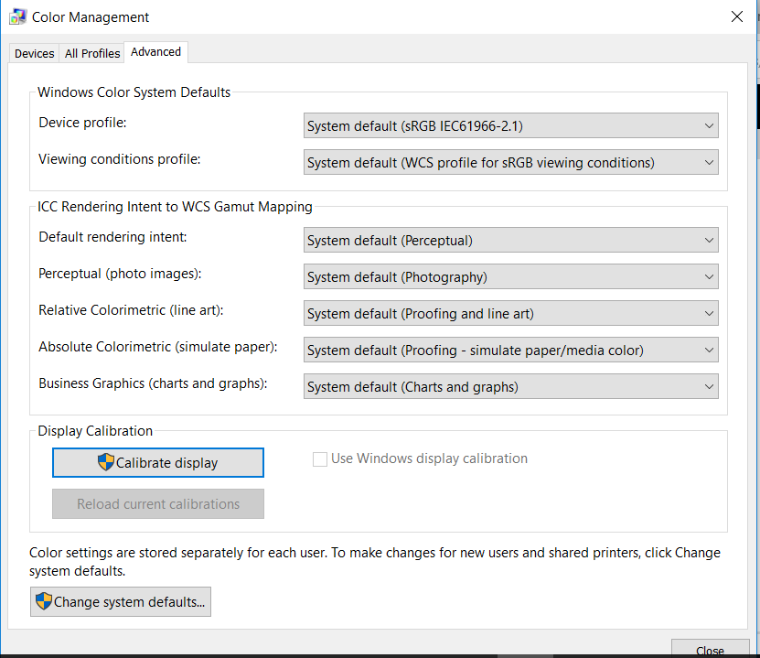

Color management manages the color displayed on your computer screen.

Credential Manager- Manages windows credential 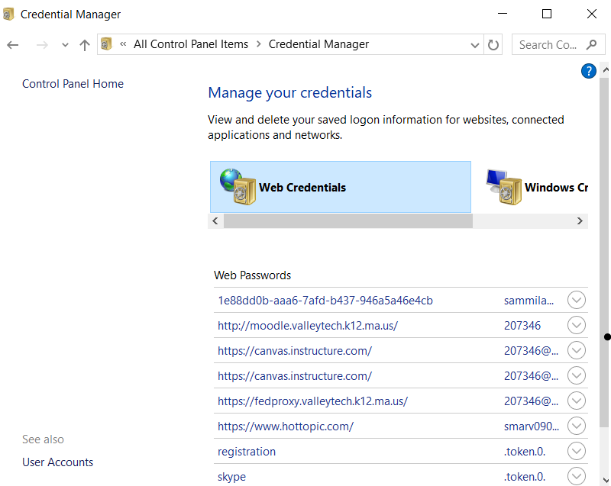 These stores recent site that need a log in and you hit the remember my account it stores in this program. If you hit show next to the password you first need to verify that its actually you. 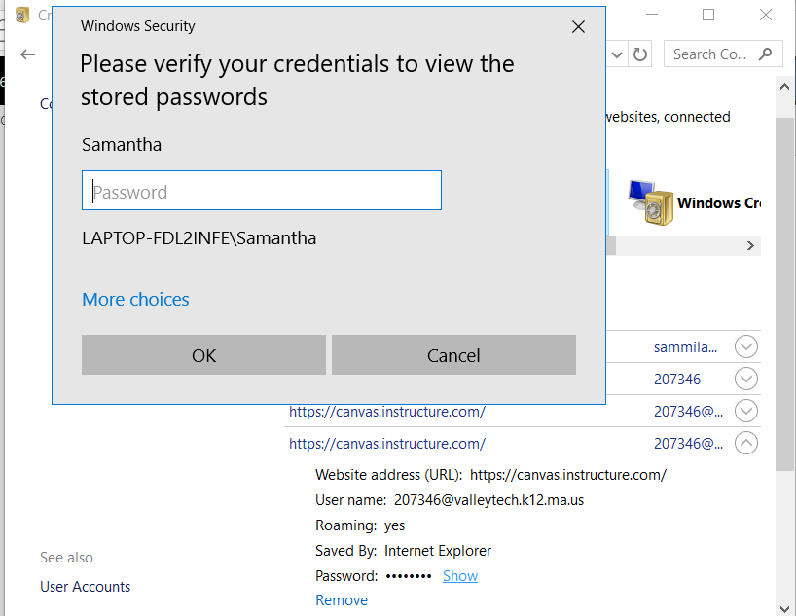

Date and Time- configure the date and time zone on your computer

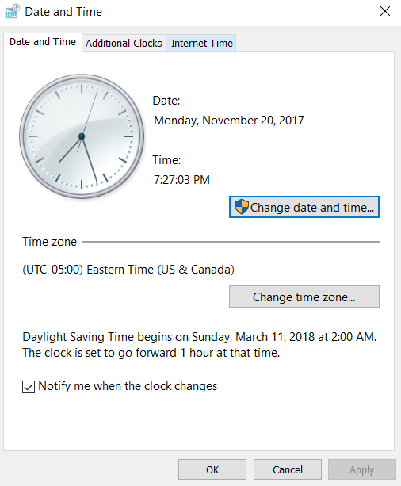 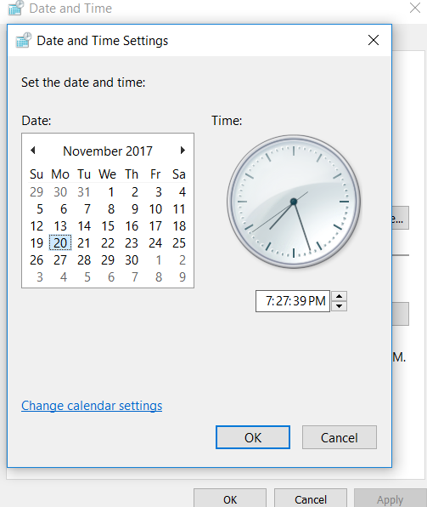

Device Manager- This program manages the different devices on your system, views and updates the hardware setting and the driver settings.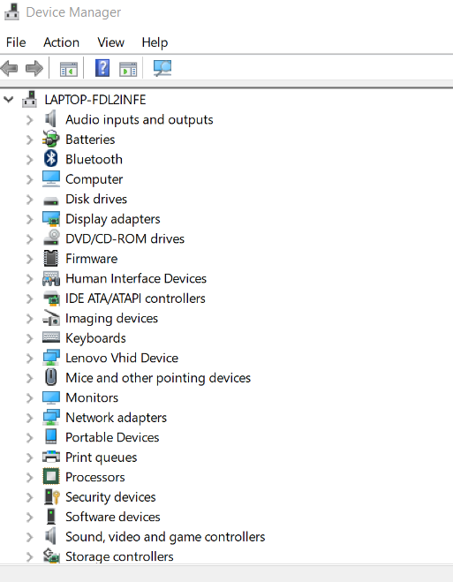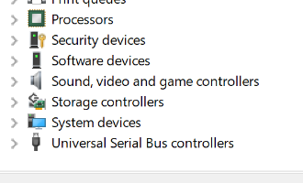

The most commonly used in device manger are Disk Drivers, and Human Interface Devices. To make any of these to work you need to double click each one, or right click and then click properties, update, to uninstall. You can also open the device manger from the start, in windows 10 you can right click the start and go up the list to find device manger. 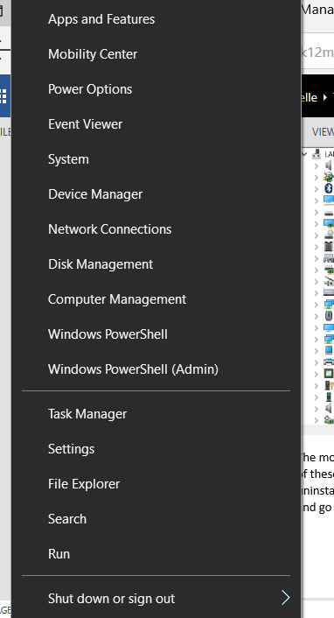

* Audio input and output- you can have a speaker and microphone set up under this.
* Batteries- A way to switch the battery if one of them isn't working properly
* Bluetooth- A wireless interacting connection. You can connect any 2 devices together as long as 1 of them have Bluetooth.
* Computer- is a device that accepts information (in the form of digitalized data) and manipulates it for some result based on a program or sequence of instructions on how the data is to be processed.
* Disk Drivers- shows the different drivers installed. Is able to update to make everything collaborate without any problems.

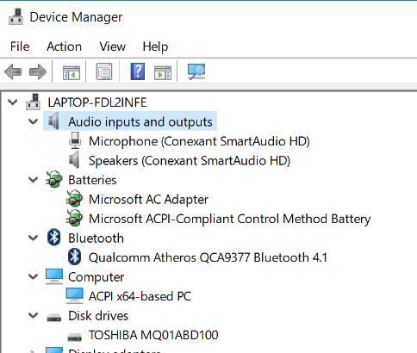

* Display Adapter- shows what adapter is installed.
* DVD/CD-ROM Drivers-The names of the driver is named and lists all the different one installed.
* Firmware- Tells if the system is working properly.
* Human Interface Devices- lists all the possible drivers installed and can be updated so it can be compatible to anything you install on your system.
* IDE ATA/ATAPI Controller- the type of he processor and the processors info.

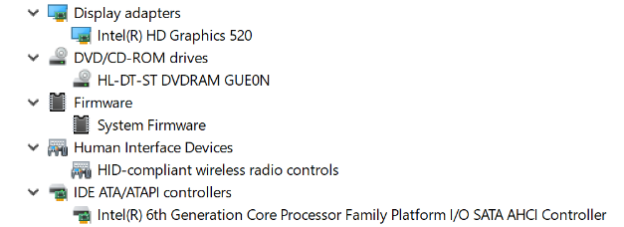

* Imaging Devices- List of the devices that can create images of the software.
* Keyboard- makes sure the keyboard is working properly
* Mice and Other Pointing Devices- Checks and allows to connect different ways to move and point at things on the screen.
* Monitors- It lists the names of the monitors that you are working off of.
* Network Adapters- lists the adapters that you have installed

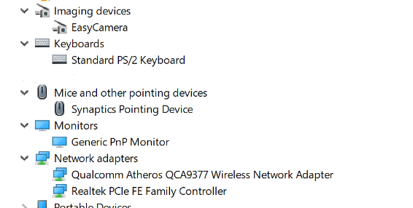

* Portable Devices- devices that you can connect to your computer, it lists them under this category
* Print Queues- lists the different printer options that installed not your system.
* Processors- lists the processors that are working on the system, and list them below. You can see the statues in the peripteries.

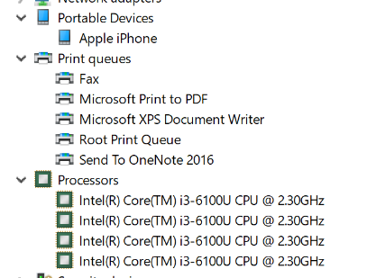

* Security Devices- shows all the trusted modules on your system
* Software Devices- all the software programs like Microsoft is listed below, all that is installed in your system
* Sound, Video, and Games Controllers- list on hat is installed for gaming, sound, and video
* Storage Controllers- A place where a software program stores data
* System Devices- all the devices on the system
* Universal Serial Bus Controller- the outside ports on the computer than you connect another devices info onto yours.

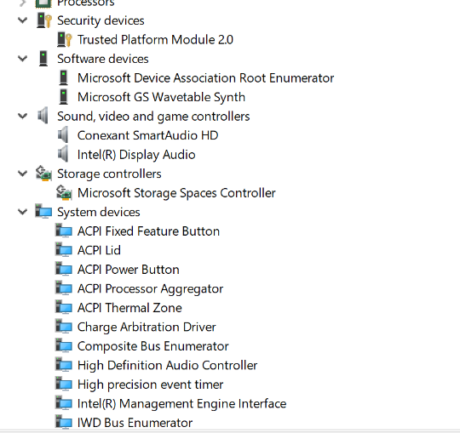 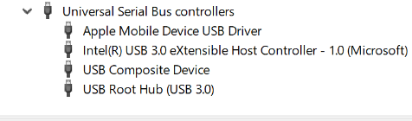

Default Programs- choose which programs you want windows to use to activate like web browsers, editing photos, sending emails, and playing music

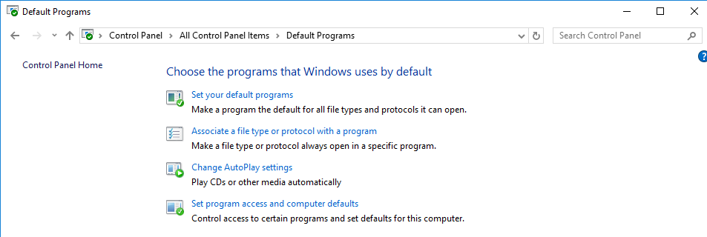

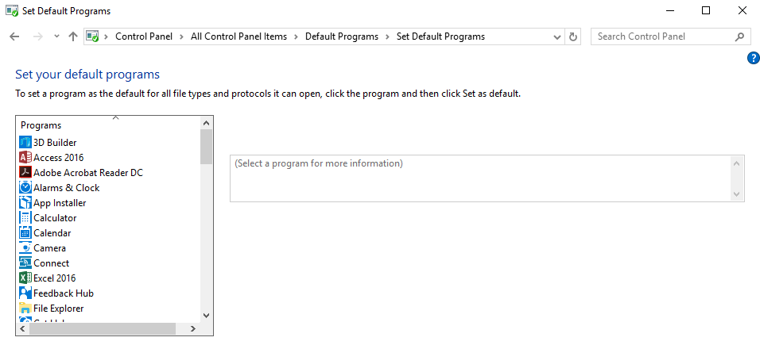

^^^^ set default programs page

Devices and Printer- manages and views devices, printers, and print jobs.

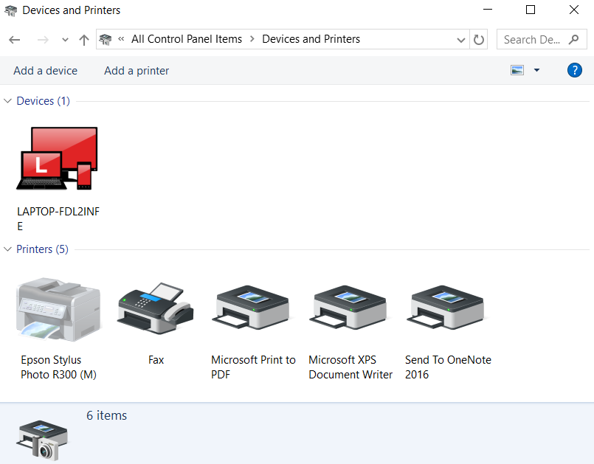 You can add devices and printers. You also can change the properties of the printers and devices. 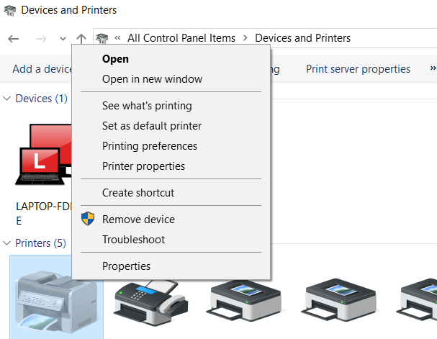

Ease of Access Center- makes the computer easier to use. 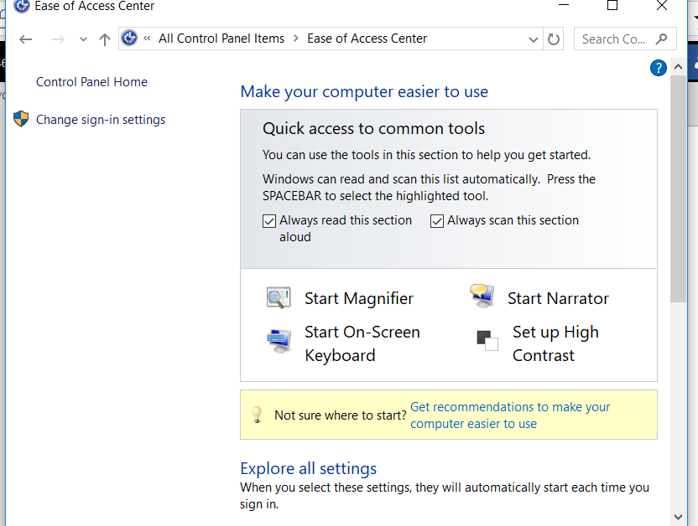 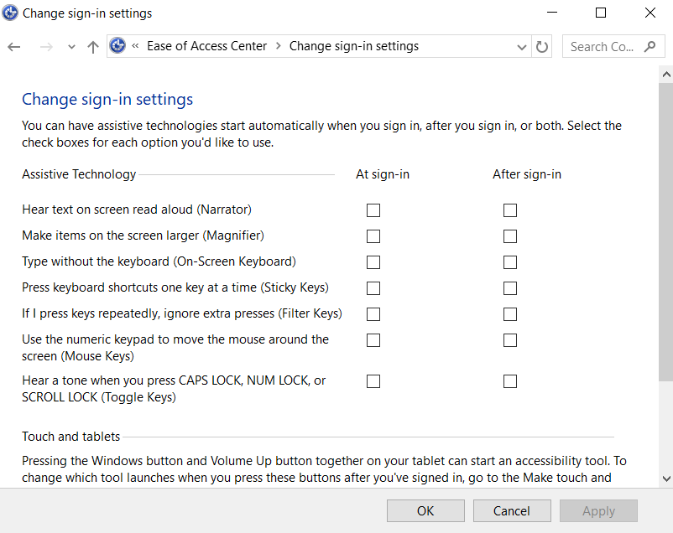 It may create your computer to used easier but, it's not as secure as it would be.

File History- All the past files that you have downloaded, read, and written. Recently, and form weeks ago.

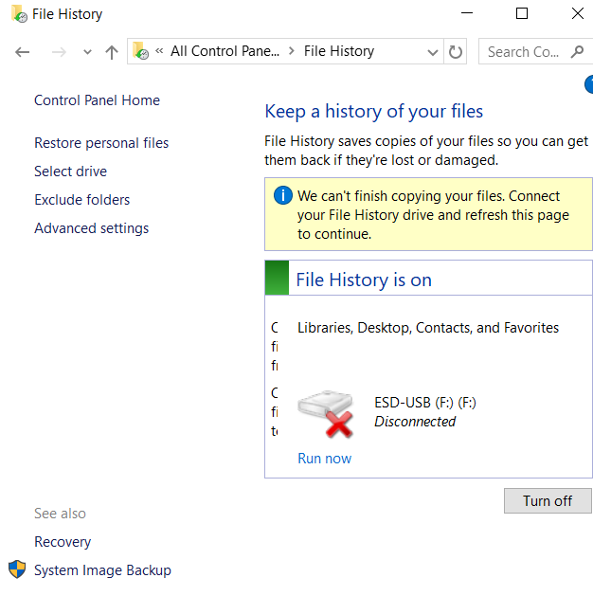If you end up deleting a file that you need you can go under recovery. There are different options for the recovery of your file.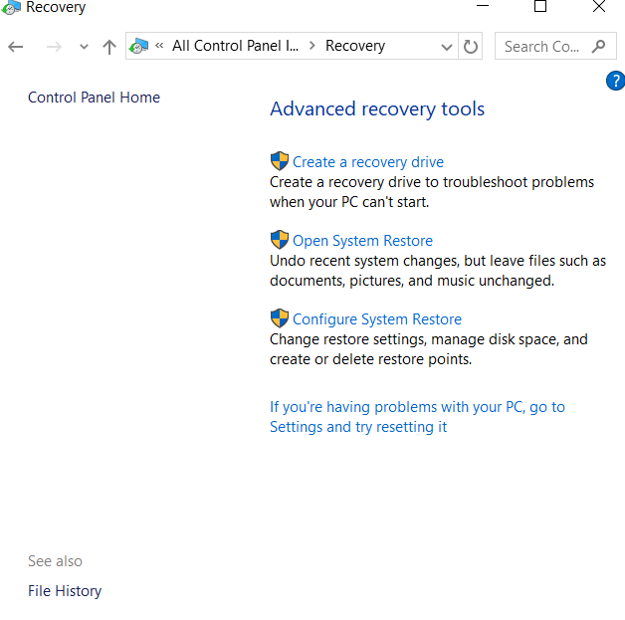 This tool is very useful for file that you might not have saved and are needed again.

Flash player(32-bit)-manages the flash player settings 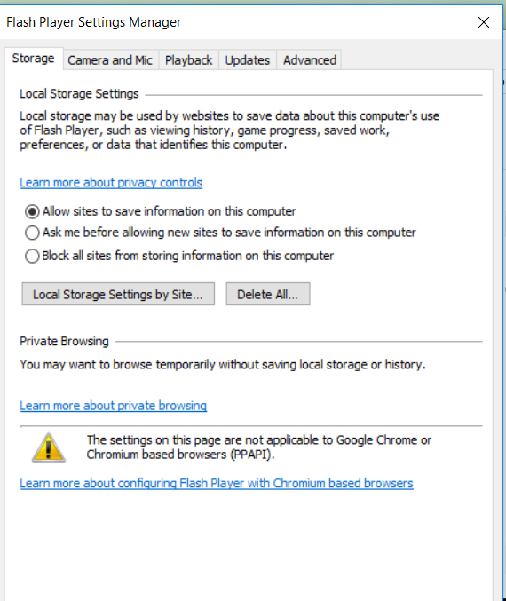This program is used for stream, and view video and multimedia. 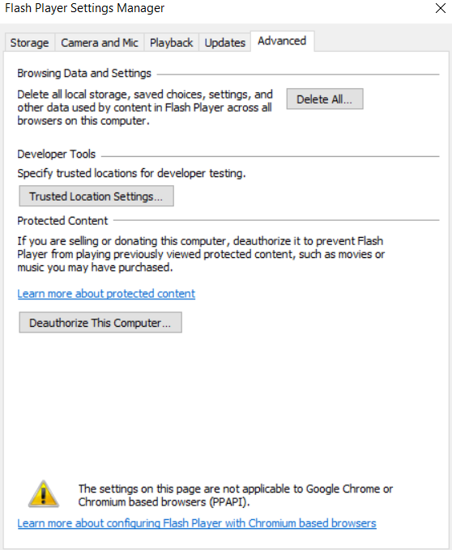

Fonts- The style, size, and color, of the words that you type onto the computer. Adds, changes, manages the font of your computer. 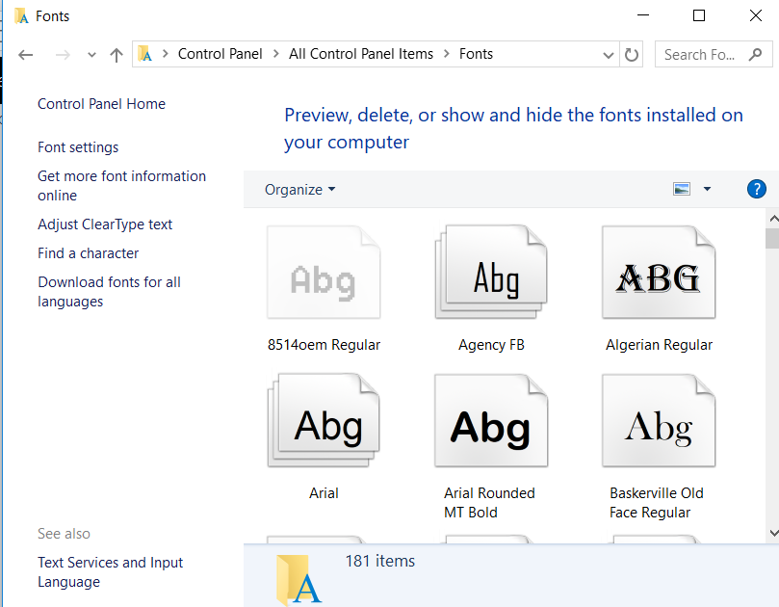 You are able to adjust the font to be cleaner have different languages and more settings about the fonts. 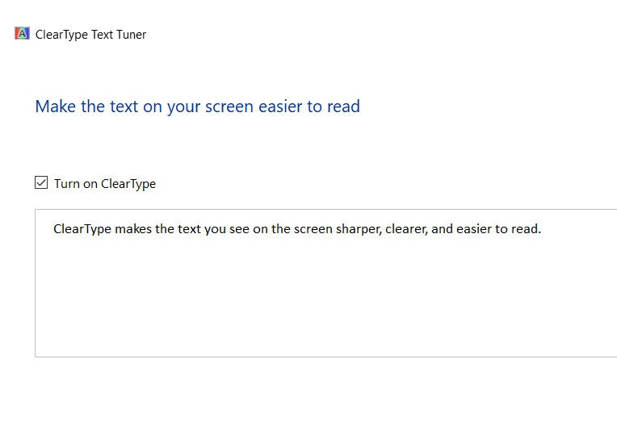

Indexing Options- Different ways to filing, that gives you more options about filing or indexing. To use Indexing Options click Modify and check the mark in the check box of the folder that you want to have indexed or uncheck to remove folder from search index.

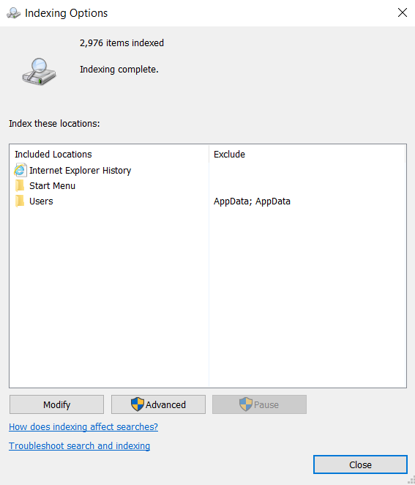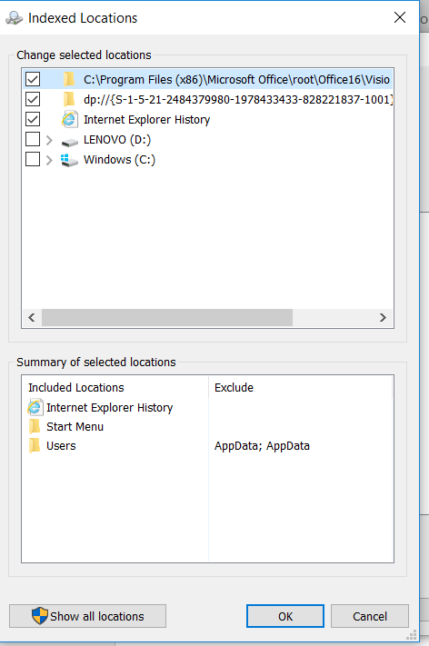

Infrared- Configures infrared files transfers, image transfers, and hardware settings.

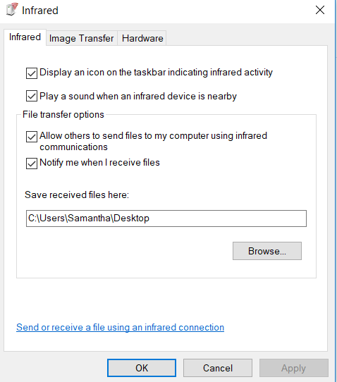 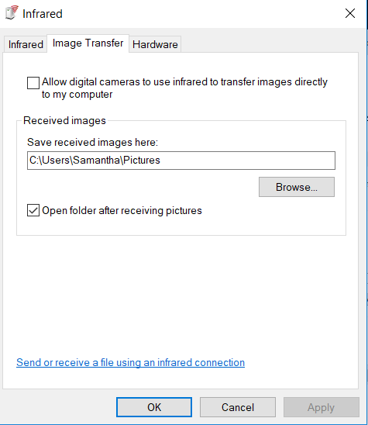

You can transfer the images to where you want and name the files.

Intel(R) Graphic and Media- controls the hardware graphics features of your computer.

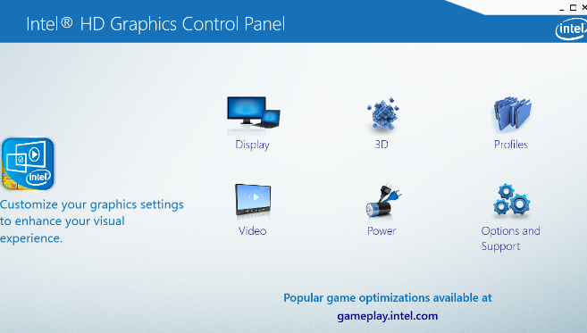 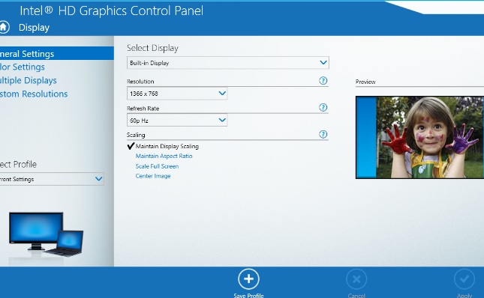 This is kind of like the setting in your computer, but more advanced.

Keyboard- the long black rectangular object that connects to the computer so you are able to type words onto the screen. 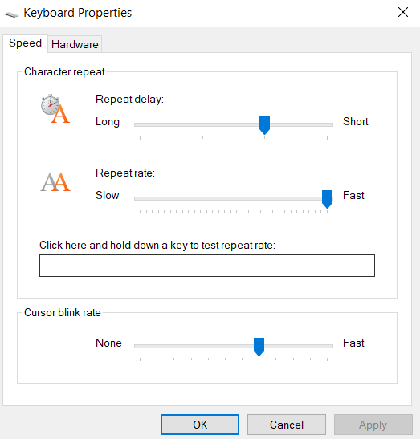 You can change the way the keyboard is able to type and the time for the letters to show up onto the screen.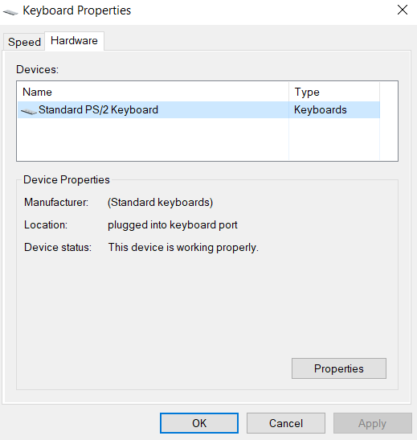

Language- you can customize the language suggestions you need and international settings.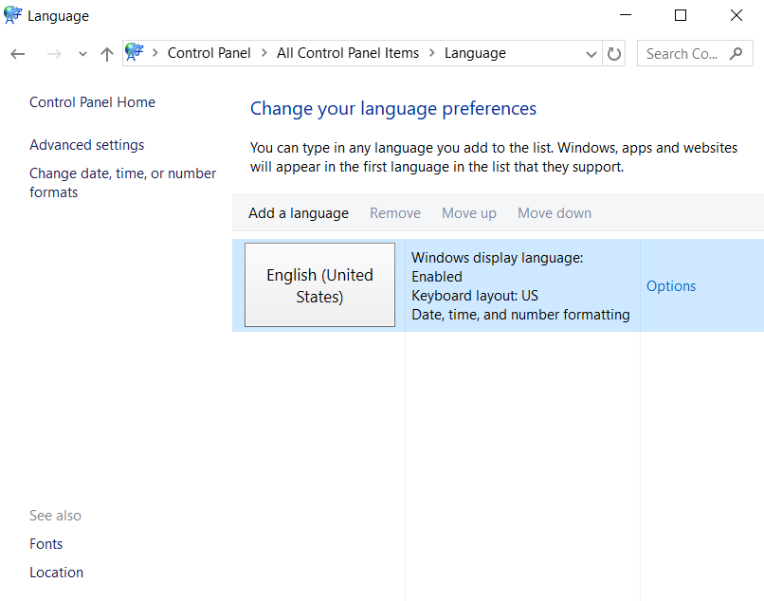 You can also read and listen to the computer. If it reads something you will be able to understand what they are saying and if you need to read something then your able to read what it says. 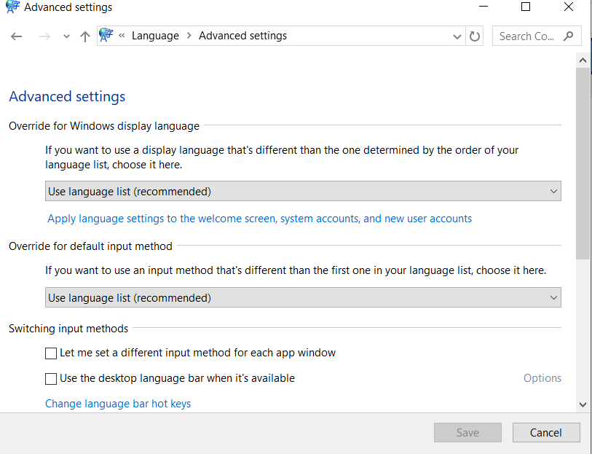

Mail (Microsoft Outlook 2016) (32-bit)- Microsoft Outlook profile

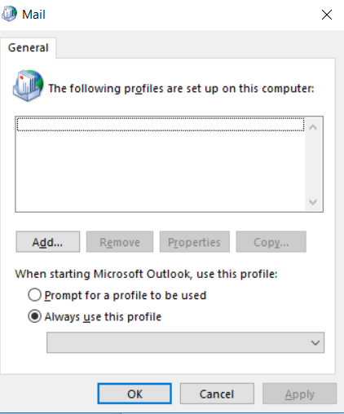 You need to add any profiles that you want to link together. So, you get to configure all the setting for that. 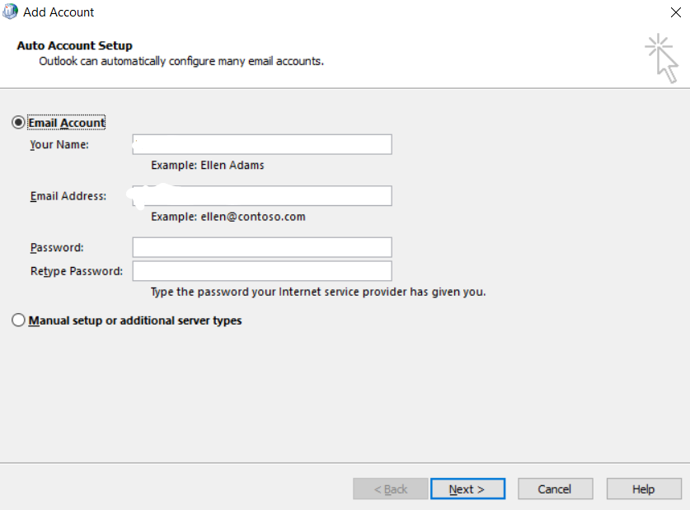

Networking and Sharing- in networking and sharing you can configure and troubleshoot a network. You can create VPN and so much more. Networking and sharing is commonly used due to the networking, and sharing. You are able to share files and folders with different people.

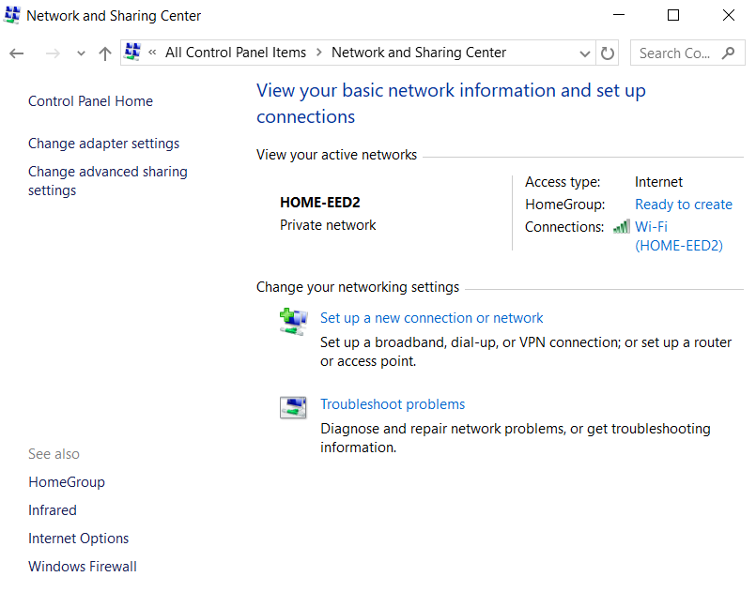You can troubleshoot if you're having issues with your network. You can also change the adapter setting through networking and sharing. For advance sharing options you can change setting of the sharing options with people.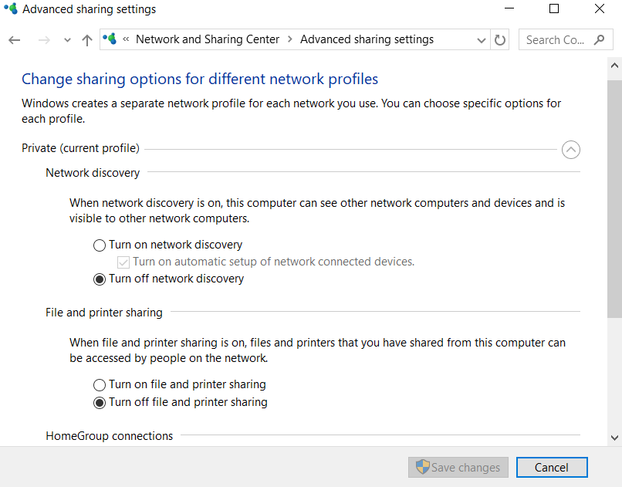

Phone and Modem- it connects the telephone dialing's rules and modem settings

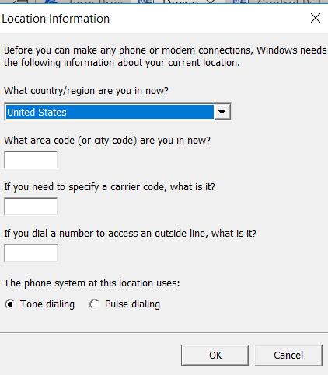

Power Options- conserve energy or maximum performance by choosing how your computers manages. power. 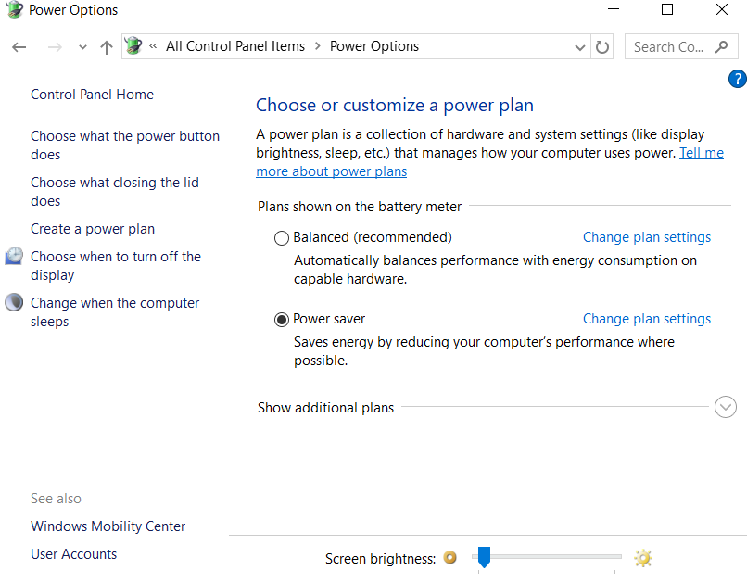 You can keep going into the system about the power options, it gets very specific for the power options. 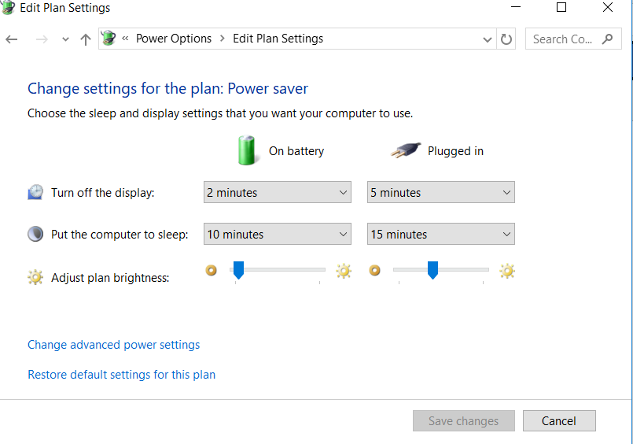

Recovery- the able to recover your system back to what is was before it was damaged, a backup of the system. You can also save a recovery of hard drives.

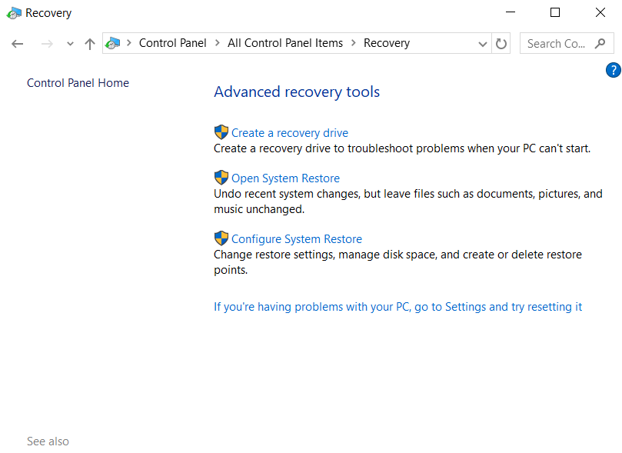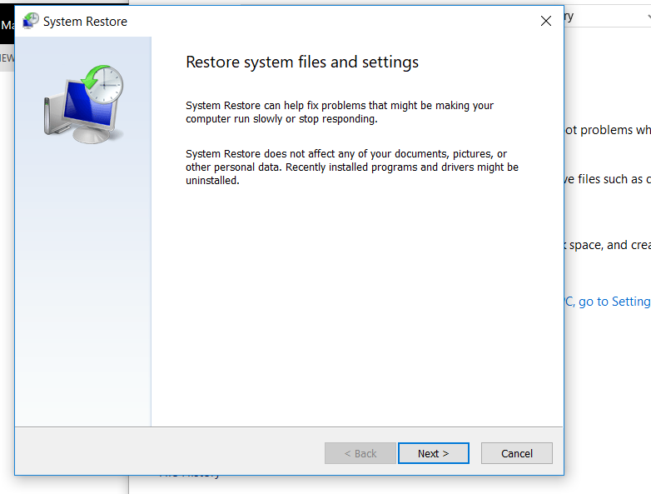System recovery for files and folders.

Region- settings for display of language, time, numbers and dates.

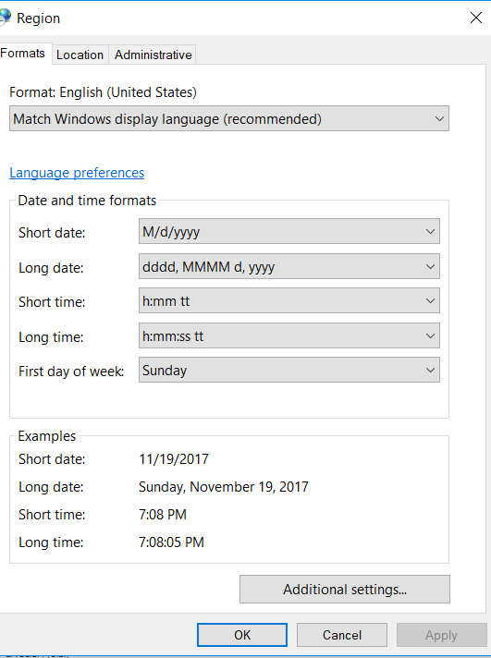 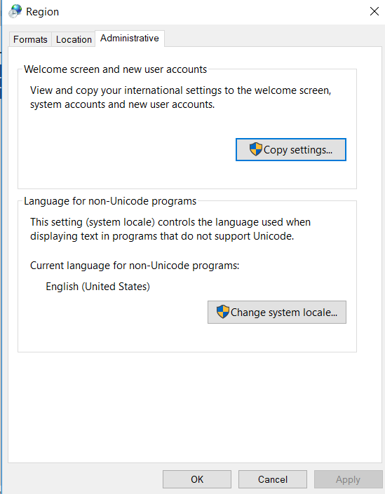 Region also needs administrative access for some of the changes to the location.

Recovery- the able to recover your system back to what is was before it was damaged, a backup of the system. You can also save a recovery ofSystem recovery for files and folders.

Region- settings for display of language, time, numbers and dates.

  Region also needs administrative access for some of the changes to the location.

Recovery- the able to recover your system back to what is was before it was damaged, a backup of the system. You can also save a recovery of hard drives.

System recovery for files and folders.

Region- settings for display of language, time, numbers and dates.

  Region also needs administrative access for some of the changes to the location.

Sound- a configure of audio devices or change scheme for your computer.

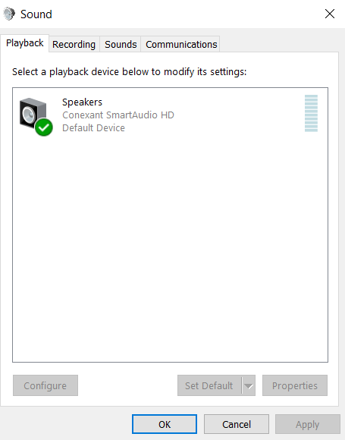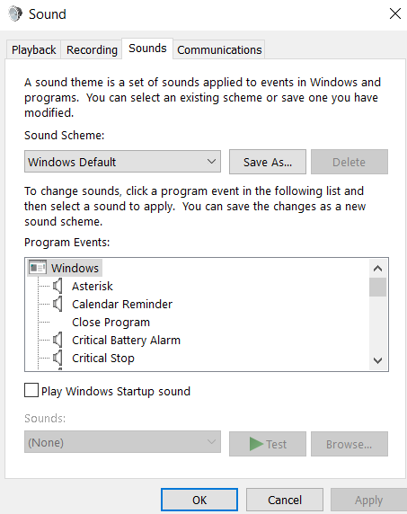

Speech Recognition- A configuration that can recognize a tone and way someone's says something to trigger a program.

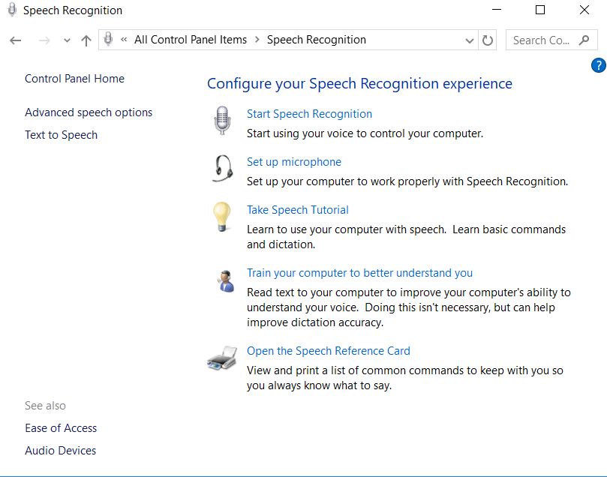 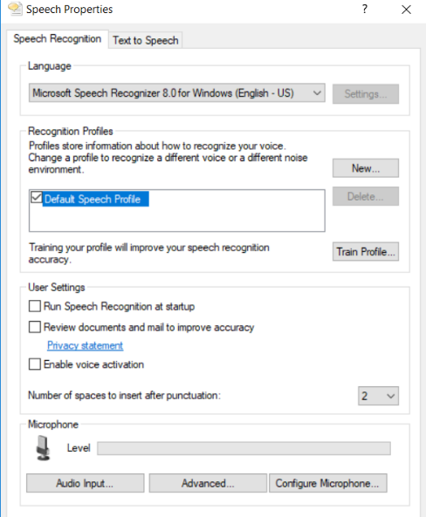

^^^^Advance option

System- View the information about your computer and changes settings for hardware, performance, and remote connections.

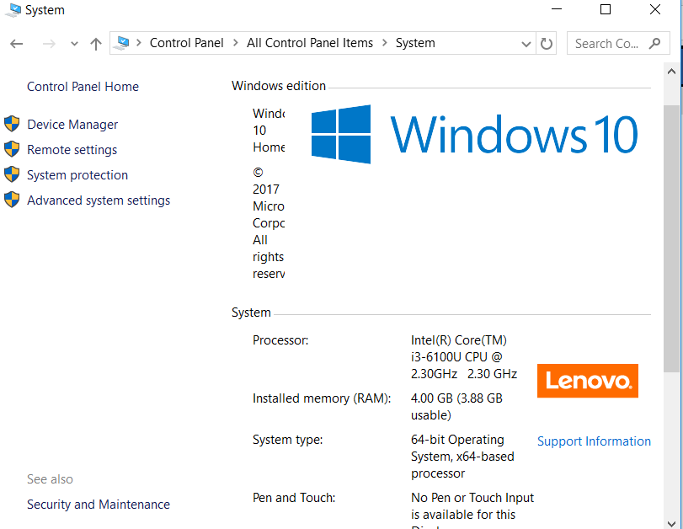Gives you information about the system and the hardware. 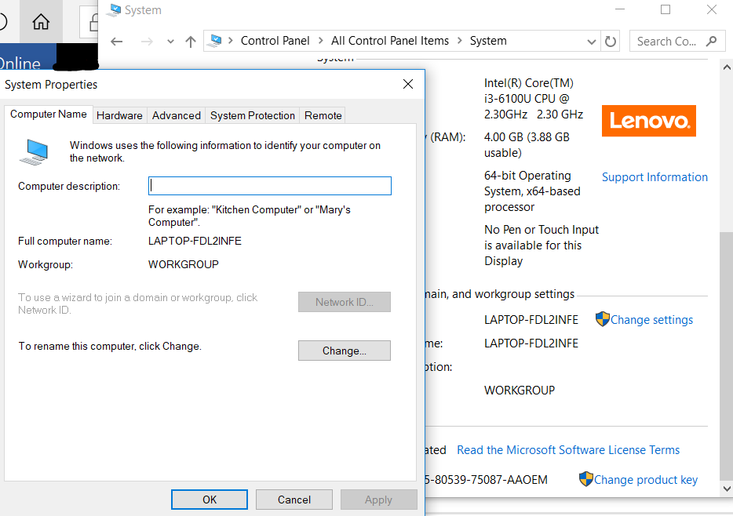 You can change the domain for the computer. You can also access device manager.

Taskbar and Navigator- The ability of customizing the taskbar, such as types of items on the display and how they should appear. Program can also be found in settings.

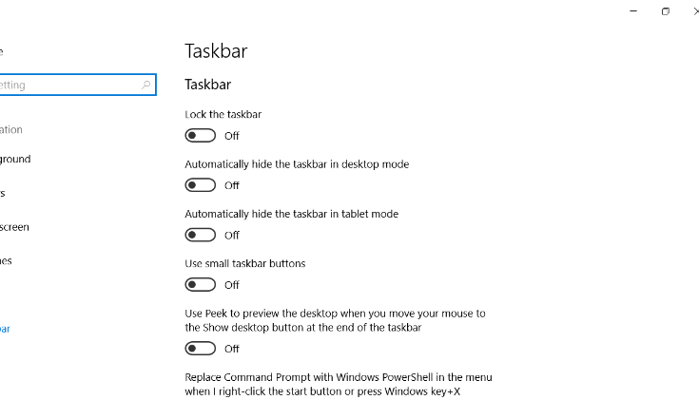 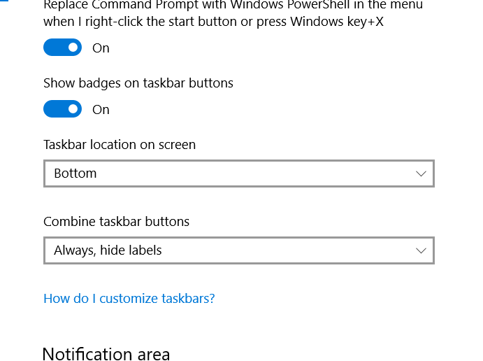

Windows Firewall- set firewall security options to help protect your computer from hackers and malicious software.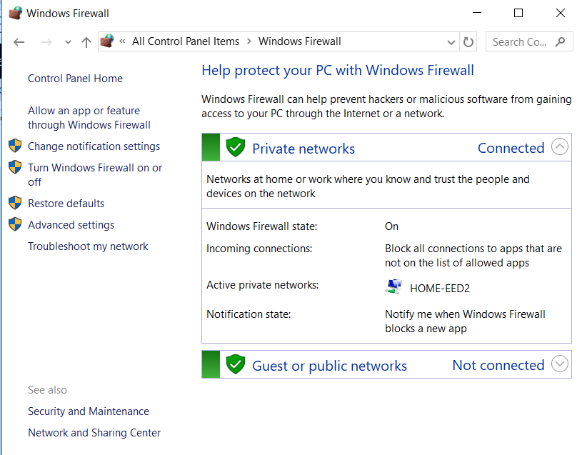

Advance setting leads you the recently tested and its shows if it passed and if not, it shows what went wrong. 